**Project Phase 3 – Face Recognition**

The dataset given is reshaped to 64*64 image format with grayscale coloring.

**BUSH MODEL**

Layers:

|  |  |
| --- | --- |
| Layers | Description |
| 2D Convolution Layer | * 32 Filters * Kernel Size (3,3)- Height and Width of 2D convolution window * Input Shape (64,64,1) * Activation function- RELU (Rectified Linear Unit) |
| MaxPooling Layer | * Pool Size (2,2) – Downscaling the input |
| Flattening Layer | * Flattens the output of MaxPooling layer to 1D to be used by Fully Connected Layer |
| Fully Connected Layer (Dense) | * 128 Units- dimensionality of output space * Activation function- RELU (Rectified Linear Unit) |
| Output Layer | * Output layer having sigmoid activation function |

The BUSH model receives an input of grayscale image with input shape (64,64,1) i.e. width 64, height 64 and grayscale color. Convolution layer computes the output of neurons that are connected to the input, each computing a dot product between their weights (3,3) and filters resulted in output parameters of 320 (32 Filters*3*3 + 32). Pooling layer performs the down sampling by factor of 2. Fully connected layer is dense layer with 128 units which computes the class scores and is connected to output layer of sigmoid function. The higher F1 score is obtained using 10 epochs for BUSH model after carefully choosing it as too high or too low epoch would result in overfitting or underfitting.

CNN Layered architecture of Bush Model is shown below.

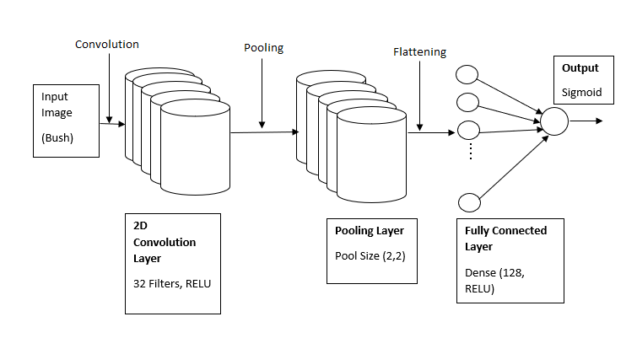

**Figure.1 CNN Layer Architecture for Bush Model**

**WILLIAMS MODEL**

Layers:

|  |  |
| --- | --- |
| Layers | Description |
| 2D Convolution Layer | * 8 Filters * Kernel Size (3,3)- Height and Width of 2D convolution window * Input Shape (64,64,1) * Activation function- RELU (Rectified Linear Unit) |
| MaxPooling Layer | * Pool Size (2,2) – Downscaling the input |
| Flattening Layer | * Flattens the output of MaxPooling layer to 1D to be used by Fully Connected Layer |
| Fully Connected Layer (Dense) | * 16 Units- dimensionality of output space * Activation function- RELU (Rectified Linear Unit) |
| Output Layer | * Output layer having sigmoid activation function |

CNN Layered architecture of Bush Model is shown below.

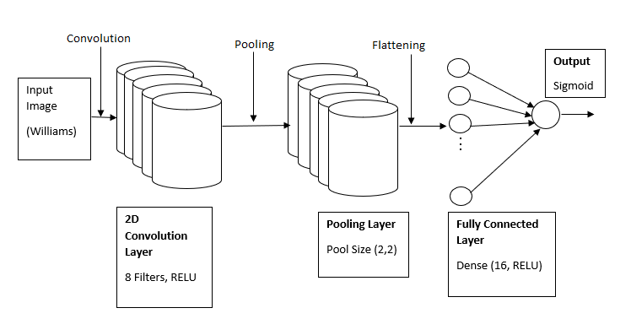

**Figure.2 CNN Layer Architecture for Williams Model**

The WILLIAMS model receives an input of grayscale image with input shape (64,64,1) i.e. width 64, height 64 and grayscale color. Convolution layer computes the output of neurons that are connected to the input, each computing a dot product between their weights (3,3) and filters resulted in output parameters of 80 (8 Filters*3*3 + 8). Pooling layer performs the down sampling by factor of 2. Fully connected layer is dense layer with 16 units which computes the class scores and is connected to output layer of sigmoid function. The higher F1 score is obtained using 10 epochs for WILLIAMS model after carefully choosing it as too high or too low epoch would result in overfitting or underfitting.